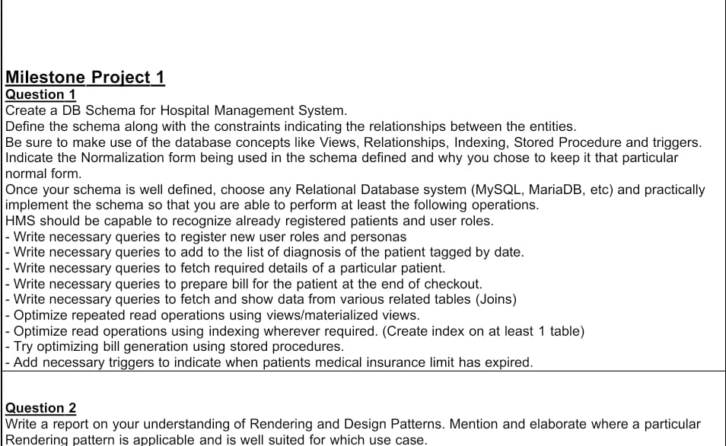

1) Create a DB Schema for Hospital Management System.

CREATE DATABASE IF NOT EXISTS hospital_management_system;

USE hospital_management_system;

2) Schema of all entity

**Patient Entity**

CREATE TABLE IF NOT EXISTS Patient (

Patient_ID INT AUTO_INCREMENT PRIMARY KEY,

Name VARCHAR(100),

Date_of_Birth DATE,

Gender VARCHAR(10),

Contact_Number VARCHAR(20),

Address VARCHAR(255),

Insurance_Limit DECIMAL(10, 2),

Insurance_Expired INT DEFAULT 0

);

Attributes: Patient_ID (Primary Key), Name, Date_of_Birth, Gender, Contact_Number, Address, Insurance_Limit, Insurance_Expired

Key Points:

Patient_ID is the primary key.

Insurance_Limit should be a positive value.

>INSERT INTO Patient (Name, Date_of_Birth, Gender, Contact_Number, Address, Insurance_Limit) VALUES

('Kaushal Patel', '2001-05-15', 'Male', '8529631475', 'Dahisar', 5000.00),

('Shruti Yadav', '2002-08-20', 'Female', '9517538524', 'Naigoan', 7000.00),

('Amaan Chaugle', '2001-12-10', 'Male', '7412589635', 'Thane', 6000.00);

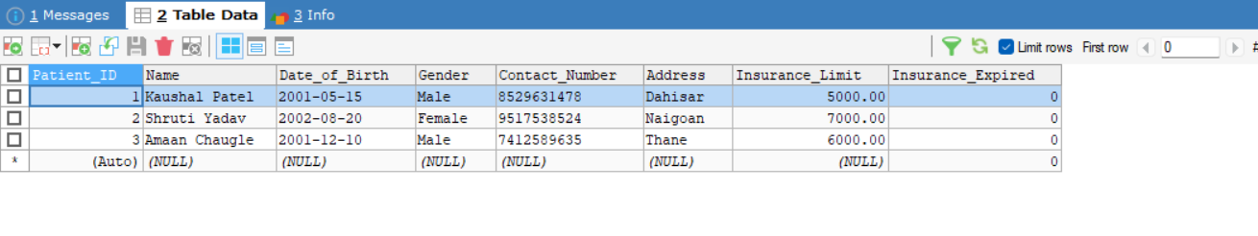

___________________________________________________________________________

**Doctor Entity**

CREATE TABLE IF NOT EXISTS Doctor (

Doctor_ID INT AUTO_INCREMENT PRIMARY KEY,

Name VARCHAR(100),

Specialization VARCHAR(100),

Contact_Number VARCHAR(20),

Email VARCHAR(100),

Department_ID INT,

Role_ID INT,

FOREIGN KEY (Department_ID) REFERENCES Department(Department_ID),

FOREIGN KEY (Role_ID) REFERENCES UserRoles(Role_ID)

);

Attributes: Doctor_ID (Primary Key), Name, Specialization, Contact_Number, Email, Department_ID (Foreign Key)

Key Points:

Doctor_ID is the primary key.

Department_ID is a foreign key referencing the Department table.

Role_ID is a foreign key referencing the UderRoles table.

Relationships: Many-to-One relationship with Departments.

>INSERT INTO Doctor (NAME, Specialization, Contact_Number, Email, Department_ID, Role_ID) VALUES

('Dr. Haresh Mehta', 'Cardiologist', '1234567890', 'drharesh@gmail.com', 1, 2),

('Dr. Dinesh Singh', 'Neurologist', '4563219874', 'drdinesh@gmail.com', 2, 2),

('Dr. Kunal Patel', 'Orthopedic Surgeon', '7594123864', 'drkunal@gmail.com', 3, 2),

('Dr. Deepti Chawla', 'Pediatrician', '9856247314', 'drdeepti@gmail.com', 4, 2);

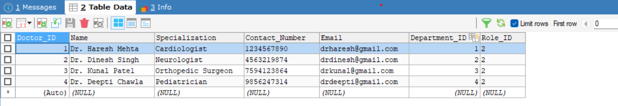

__________________________________________________________________________________

**Department Entity**

CREATE TABLE IF NOT EXISTS Department (

Department_ID INT AUTO_INCREMENT PRIMARY KEY,

Department_Name VARCHAR(100)

);

Attributes: Department_ID (Primary Key), Department_Name

Key Points:

Department_ID is the primary key.

Relationships: One-to-Many relationship with Doctors.

>INSERT INTO Department (Department_Name) VALUES

('Cardiology'),

('Neurology'),

('Orthopedics'),

(‘Pediatrics’);

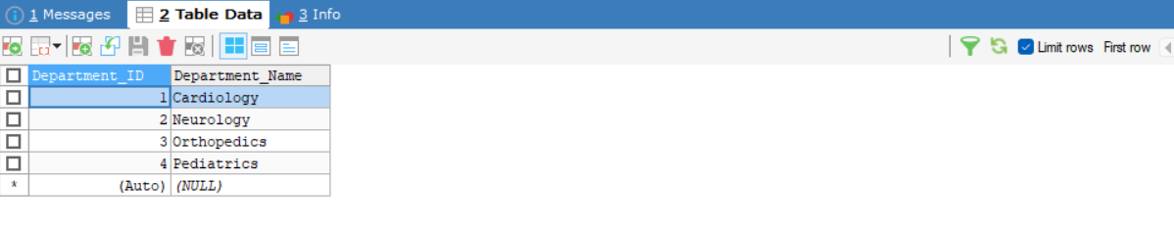

___________________________________________________________________________

**Disease Entity**

CREATE TABLE IF NOT EXISTS Disease (

Disease_ID INT AUTO_INCREMENT PRIMARY KEY,

Disease_Name VARCHAR(100),

Description TEXT,

Treatment TEXT

);

Attributes: Disease_ID (Primary Key), Disease_Name, Description, Treatment

Key Points:

Disease_ID is the primary key.

>INSERT INTO Diseases (Disease_Name, Description, Treatment) VALUES

('Heart Disease', Heart Disease involves problems with the heart and blood vessels ', 'Treatment for heart disease'),

('Migraine', It is a type of headache disorder causing severe pain ', 'Treatment for migraine'),

('Fracture', A Fracture is a broken bone, leading to pain, swelling in the injured area ', 'Treatment for fracture'),

('Fever', ' Fever is a raised body temperature, caused by infection or inflammation, 'Treatment for fever');

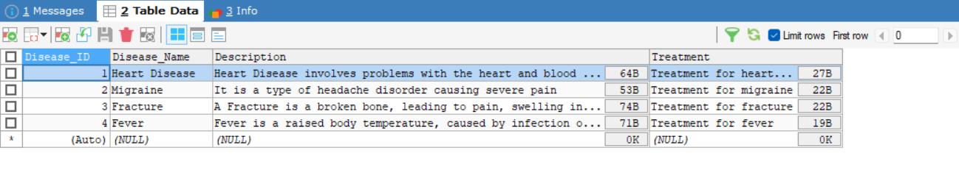___________________________________________________________________________

**Appointment Entity**

CREATE TABLE IF NOT EXISTS Appointment (

Appointment_ID INT AUTO_INCREMENT PRIMARY KEY,

Patient_ID INT,

Doctor_ID INT,

Appointment_Date DATE,

Appointment_Time TIME,

Appointment_Status VARCHAR(20),

Disease_ID INT,

FOREIGN KEY (Patient_ID) REFERENCES Patient(Patient_ID),

FOREIGN KEY (Doctor_ID) REFERENCES Doctor(Doctor_ID),

FOREIGN KEY (Disease_ID) REFERENCES Disease(Disease_ID)

);

Attributes: Appointment_ID (Primary Key), Patient_ID (Foreign Key), Doctor_ID (Foreign Key), Appointment_Date, Appointment_Time, Appointment_Status, Disease_ID (Foreign Key)

KeyPoints:

Appointment_ID is the primary key.

Patient_ID and Doctor_ID are foreign keys referencing the Patients and Doctors tables respectively.

Relationships:

Many-to-One relationship with Patients and Doctors.

Many-to-One relationship with Diseases.

>INSERT INTO Appointments (Patient_ID, Doctor_ID, Appointment_Date, Appointment_Time, Appointment_Status, Disease_ID) VALUES

(1, 1, '2024-02-10', '10:00:00', 'Scheduled', 1),

(2, 2, '2024-02-12', '11:00:00', 'Scheduled', 2),

(3, 3, '2024-02-15', '09:00:00', 'Scheduled', 3),

(1, 4, '2024-02-20', '12:00:00', 'Scheduled', 4);

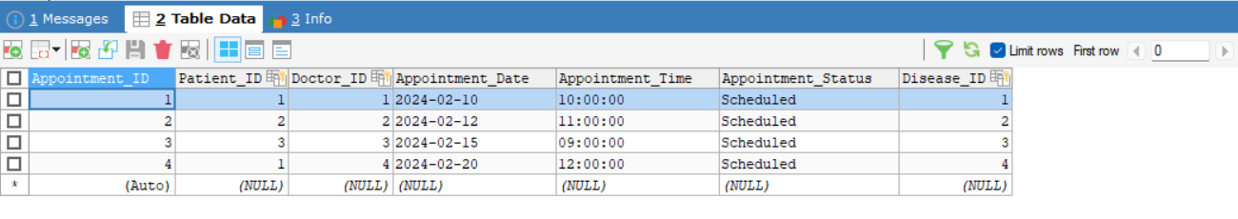

___________________________________________________________________________

**Billing Entity**

CREATE TABLE IF NOT EXISTS Billing (

Bill_ID INT AUTO_INCREMENT PRIMARY KEY,

Patient_ID INT,

Appointment_ID INT,

Disease_ID INT,

Total_Amount DECIMAL(10, 2),

Payment_Status VARCHAR(20),

Billing_Date DATE,

FOREIGN KEY (Patient_ID) REFERENCES Patient(Patient_ID),

FOREIGN KEY (Appointment_ID) REFERENCES Appointment(Appointment_ID),

FOREIGN KEY (Disease_ID) REFERENCES Disease(Disease_ID)

);

Attributes: Bill_ID (Primary Key), Patient_ID (Foreign Key), Appointment_ID (Foreign Key), Disease_ID (Foreign Key), Total_Amount, Payment_Status, Billing_Date

Key Points:

Bill_ID is the primary key.

Patient_ID, Appointment_ID, and Disease_ID are foreign keys referencing Patients, Appointments, and Diseases tables respectively.

Relationships:

Many-to-One relationship with Patients, Appointments, and Diseases.

> INSERT INTO Billing (Patient_ID, Appointment_ID, Disease_ID, Total_Amount, Payment_Status, Billing_Date) VALUES

(1, 1, 1, 150.00, 'Pending', '2024-02-10'),

(2, 2, 2, 200.00, 'Pending', '2024-02-12'),

(3, 3, 3, 300.00, 'Pending', '2024-02-15'),

(1, 4, 4, 100.00, 'Pending', '2024-02-20');

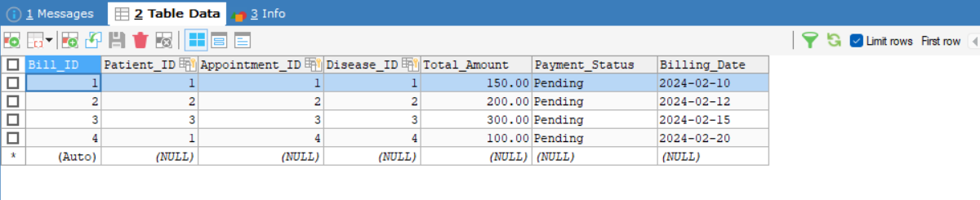

___________________________________________________________________________

**UserRoles Entity**

CREATE TABLE IF NOT EXISTS UserRoles (

Role_ID INT AUTO_INCREMENT PRIMARY KEY,

Role_Name VARCHAR(100) UNIQUE

);

The User Role table defines different roles that users can have within the system.Examples of user roles in an HMS may include "Admin", "Doctor", "Nurse", "Receptionist", etc.

Each user role represents a set of permissions and access levels within the system.

> INSERT INTO UserRoles (Role_Name) VALUES

('Administrator'),

('Doctor'),

('Nurse'),

('Receptionist');

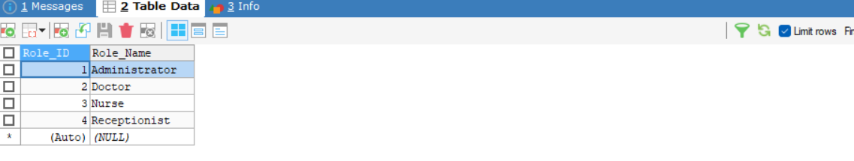

___________________________________________________________________________

**UserPersonas Entity**

CREATE TABLE IF NOT EXISTS UserPersonas (

User_ID INT AUTO_INCREMENT PRIMARY KEY,

Role_ID INT,

Name VARCHAR(100),

Contact_Number VARCHAR(20),

Email VARCHAR(100),

FOREIGN KEY (Role_ID) REFERENCES UserRoles(Role_ID)

);

The User Persona table defines specific personas or profiles that users can have within a role.

> INSERT INTO UserPersonas (Role_ID, Name, Contact_Number, Email) VALUES

(1, 'Admin Ankit Yadav ', '123456789', 'admin@gmail.com'),

(2, 'Dr. Sanket Jain', '987654321', 'drsanket@gmail.com'),

(3, 'Nurse Mansi Patil', '111222333', 'nursemansi@gmail.com'),

(4, 'Receptionist Vikiy Patak', '999888777', 'receptionistpatak@gmail.com');

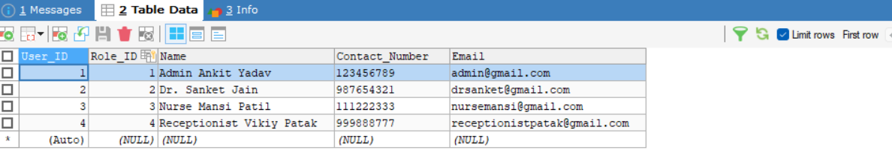

__________________________________________________________________________________

3) Indicate the Normalization form being used in the schema defined and why you chose to keep it that particular normal form?

->The HMS schema follows the Third Normal Form (3NF) by ensuring:

No repeating groups exist in tables.

Each table appears to represent a distinct entity (e.g., Patient, Doctor, Appointment, etc.), and there are no repeating groups within these tables. Each column holds atomic values.

Non-key attributes are fully functionally dependent on the primary key.

In the Patient table, attributes like Name, Date_of_Birth, Gender, etc., are functionally dependent on the Patient_ID. Similarly, in other tables like Doctor, Appointment, and Billing, attributes seem to depend on their respective primary keys.

There are no transitive dependencies between non-key attributes.

There don't appear to be any transitive dependencies in the schema. Each non-key attribute seems to depend only on the primary key of its respective table, and not on other non-key attributes.

4) Write necessary queries to register new user roles and personas

Query to register a new user role:

>INSERT INTO UserRole(Role_Name) VALUES (‘**Pharmacist**');

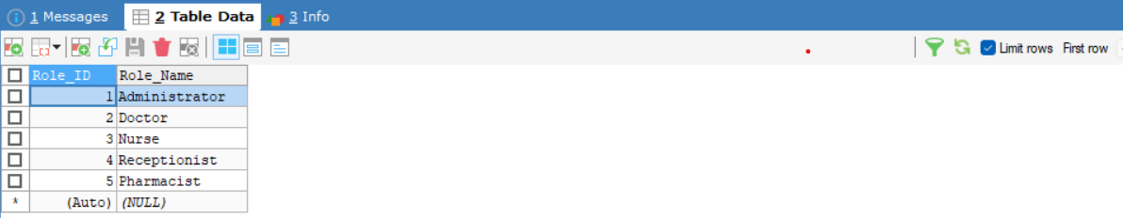

Query to register a new user persona associated with the newly created user role’

> INSERT INTO UserPersonas (Role_ID, Name, Contact_Number, Email) VALUES (5, 'Sandeep Pharmacist', '1122334455', sandeeppharma@gmail.com);

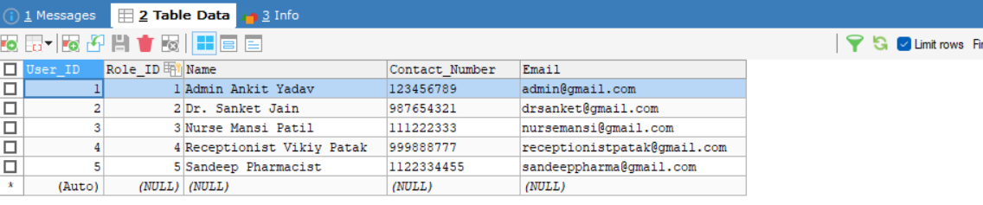

5) Write necessary queries to add to the list of diagnosis of the patient tagged by date.

> INSERT INTO Appointment (Patient_ID, Doctor_ID, Appointment_Date, Appointment_Time, Appointment_Status, Disease_ID)

VALUES (3, 1, '2024-02-06', '10:00', 'Diagnosed', 1);

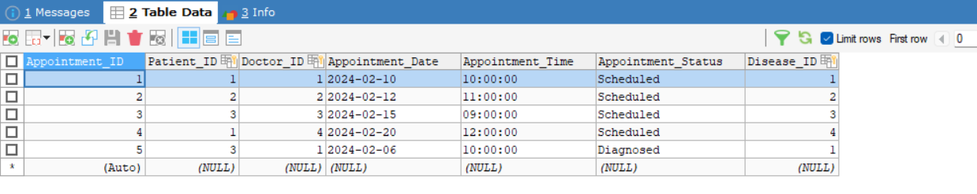

6) Write necessary queries to fetch required details of a particular patient.

> SELECT * FROM Patient WHERE Patient_ID = 1;

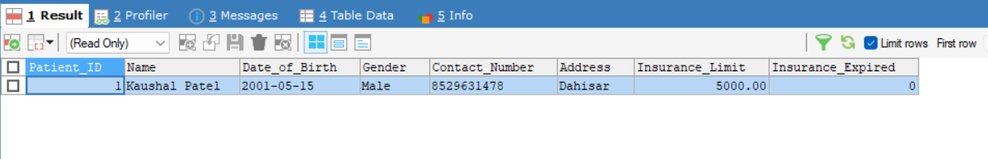

7) Write necessary queries to prepare bill for the patient at the end of checkout.

-> First, I have checked how many appointments there are for a particular patient.

>SELECT COUNT(*) AS Total_Appointments

FROM Appointment

WHERE Patient_ID = 1;

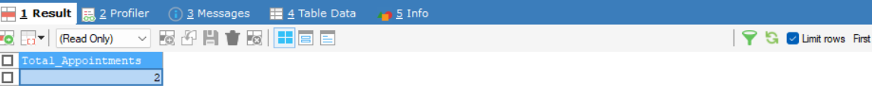

-> Then, I have calculated the total amount of those appointments.

> SELECT Patient_ID, SUM(Total_Amount) AS Total_Amount

FROM Billing

WHERE Patient_ID = 1

AND Payment_Status = 'Pending';

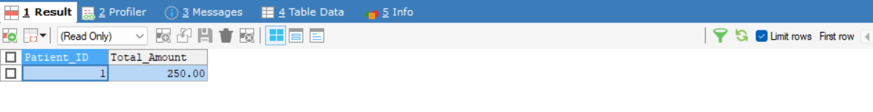

8) Write necessary queries to fetch and show data from various related tables (Joins)

> SELECT A.Appointment_ID, P.Name AS Patient_Name, D.Name AS Doctor_Name, A.Appointment_Date, A.Appointment_Time

FROM Appointments A

JOIN Patient P ON A.Patient_ID = P.Patient_ID

JOIN Doctor D ON A.Doctor_ID = D.Doctor_ID;

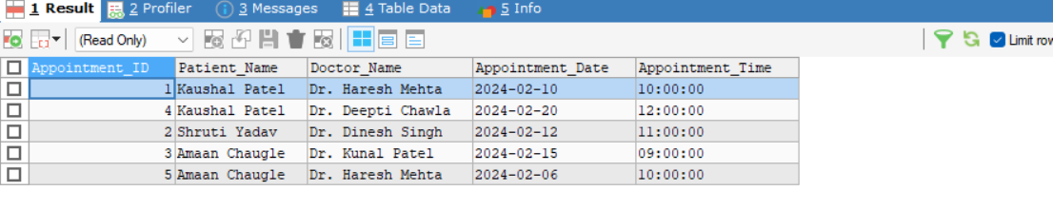

> SELECT B.Bill_ID, P.Name AS Patient_Name, D.Name AS Doctor_Name, DS.Disease_Name, B.Total_Amount, B.Payment_Status, B.Billing_Date

FROM Billing B

JOIN Appointments A ON B.Appointment_ID = A.Appointment_ID

JOIN Patient P ON A.Patient_ID = P.Patient_ID

JOIN Doctor D ON A.Doctor_ID = D.Doctor_ID

JOIN Diseases DS ON B.Disease_ID = DS.Disease_ID;

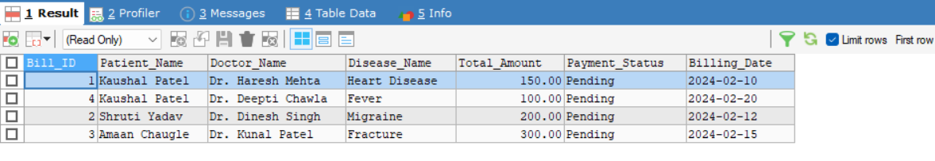

> SELECT A.Appointment_ID, P.Name AS Patient_Name, DS.Disease_Name, DPT.Department_Name, A.Appointment_Date, A.Appointment_Time

FROM Appointments A

JOIN Patient P ON A.Patient_ID = P.Patient_ID

JOIN Diseases DS ON A.Disease_ID = DS.Disease_ID

JOIN Doctor D ON A.Doctor_ID = D.Doctor_ID

JOIN Department DPT ON D.Department_ID = DPT.Department_ID;

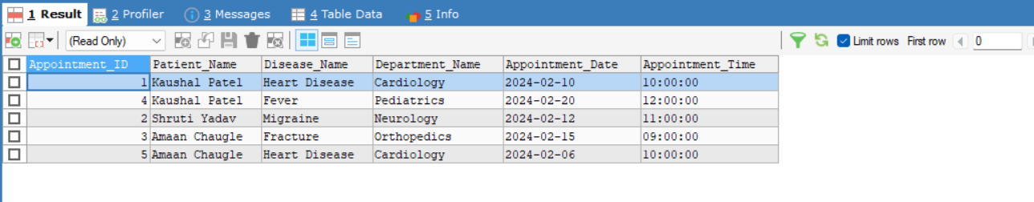

9) Optimize repeated read operations using views/materialized views.

> CREATE VIEW TotalBillingPerPatient AS

SELECT Patient_ID, SUM(Total_Amount) AS Total_Billing_Amount

FROM Billing

GROUP BY Patient_ID;

> SELECT * FROM TotalBillingPerPatient;

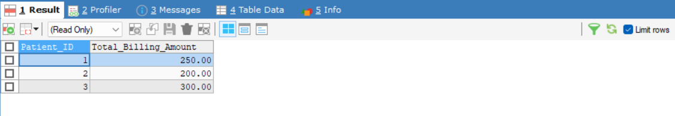

> CREATE VIEW AppointmentsPerDoctor AS

SELECT d.Doctor_ID, d.Name AS Doctor_Name, a.Appointment_ID, a.Appointment_Date, a.Appointment_Time

FROM Doctor d

LEFT JOIN Appointment a ON d.Doctor_ID = a.Doctor_ID;

> SELECT * FROM AppointmentsPerDoctor;

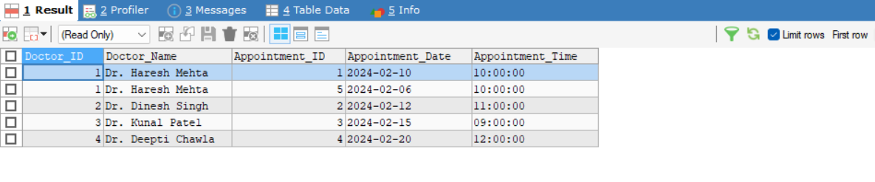

10) Optimize read operations using indexing wherever required. (Create index on at least 1 table)

> CREATE INDEX idx_patient_id ON Patient(Patient_ID);

> SELECT * FROM Patient WHERE Patient_ID = 1;

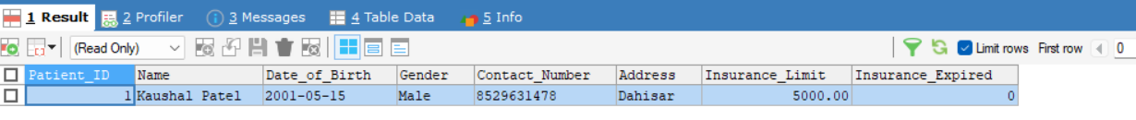

11) Try optimizing bill generation using stored procedures.

> DELIMITER //

CREATE PROCEDURE GenerateBill(IN patientID INT)

BEGIN

DECLARE totalAmount DECIMAL(10, 2);

SELECT SUM(Total_Amount)

INTO totalAmount

FROM Billing

WHERE Patient_ID = patientID;

INSERT INTO Billing (Patient_ID, Total_Amount, Billing_Date, Payment_Status)

VALUES (patientID, totalAmount, CURDATE(), 'Pending');

END//

DELIMITER ;

> CALL GenerateBill(1);

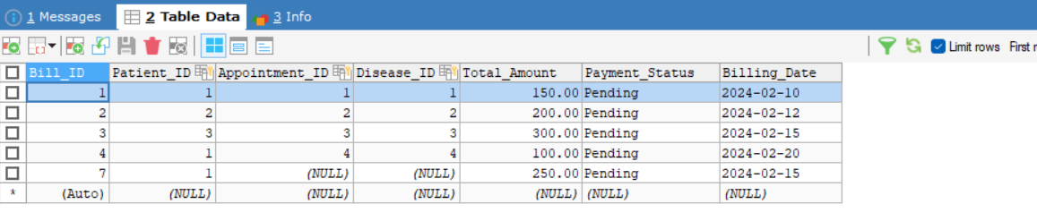

12) Add necessary triggers to indicate when patients medical insurance limit has expired.

> DELIMITER //

CREATE TRIGGER CheckInsuranceLimit

AFTER INSERT ON Appointment

FOR EACH ROW

BEGIN

DECLARE totalAmount DECIMAL(10, 2);

DECLARE insuranceLimit DECIMAL(10, 2);

SELECT SUM(D.Price)

INTO totalAmount

FROM Appointment A

LEFT JOIN Disease D ON A.Disease_ID = D.Disease_ID

WHERE A.Patient_ID = NEW.Patient_ID;

SELECT Insurance_Limit

INTO insuranceLimit

FROM Patient

WHERE Patient_ID = NEW.Patient_ID;

IF totalAmount > insuranceLimit THEN

UPDATE Patient

SET Insurance_Expired = 1

WHERE Patient_ID = NEW.Patient_ID;

END IF;

END;

//

DELIMITER ;

> INSERT INTO Billing (Patient_ID, Appointment_ID, Disease_ID, Total_Amount, Payment_Status, Billing_Date) VALUES

(1, 1, 1, 5100.00, 'Pending', '2024-02-19');

